**Amazon Registration Form**

**URL TESTING**

<https://www.amazon.in/ap/register?_encoding=UTF8&openid.assoc_handle=inflex&openid.claimed_id=http%3A%2F%2Fspecs.openid.net%2Fauth%2F2.0%2Fidentifier_select&openid.identity=http%3A%2F%2Fspecs.openid.net%2Fauth%2F2.0%2Fidentifier_select&openid.mode=checkid_setup&openid.ns=http%3A%2F%2Fspecs.openid.net%2Fauth%2F2.0&openid.ns.pape=http%3A%2F%2Fspecs.openid.net%2Fextensions%2Fpape%2F1.0&openid.pape.max_auth_age=0&openid.return_to=https%3A%2F%2Fwww.amazon.in%2Fgp%2Fyourstore%2Fhome%3Fie%3DUTF8%26ref_%3Dnav_newcust>

After clicking on above amazon registration link the registration page will open.

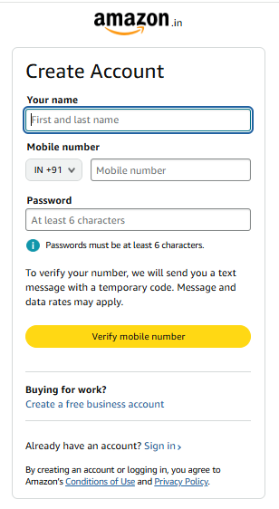

**URL Testing: PASS**

**GUI TESTING:**

* Amazon logo should be in middle of page in lower case with black colour.

Result: - Pass

* Below that Create Account name should be present in a black colour with first letter capital.

Result: - Pass

* Below that name, mobile number and password tab need to be present in black colour text.

Result: - Pass

* Below that verify mobile number tab need to be present in orange colour with black colour text.

Result: - Pass

**GUI (GRAPHICAL USER INTERFACE) TESTING: DONE**

**SERVICE LEVEL TESTING:**

* Amazon logo should in centre of the page.

Result: - Pass

* Create Account should be in left upper corner of the box.

Result: - Pass

* Name, Mobile Number and Password should exactly below each other.

Result: - Pass

* At last Verify Mobile Number button should be at last.

Result: - Pass

**SERVICE LEVEL TESTING: DONE**

**Software Requirement Specification (SRS)**

1. Full name should be accepting alphabets only along with size should be 2 to 30 characters.
2. Full Name should be accepting black spaces between words.
3. Mobile number should be accepting numbers only and its size should be 14.
4. Password should be accepting Alphabets, Numbers and Special characters.
5. Password must contain at least 8 character along with the combination of 1 uppercase, 1 lowercase and 1 numeric character.

**Boundary Value Analysis (BVA):**

**For Name:**

Min = 2

Max = 30

* Does it accept 2 alphabets?

Yes=PASS

* Does it accept 30 alphabets?

Yes=PASS

* Does it accept Min+1= 3 alphabets?

Yes=PASS

* Does it accept Min-1=1 alphabets?

Yes=FAIL

* Does it accept Max+1=31 alphabets?

Yes=FAIL

* Does it accept Max-1=29 alphabets?

Yes=FAIL

**For Mobile Number:**

Min & Max= 14

* Does it accept Numeric numbers?

Yes=PASS

* Does it accept 14 numbers?

Yes=PASS

* Does it accept <14 numbers?

NO=PASS

* Does it accept >14 numbers?

NO=PASS

**For Password:**

Min = 8

Max = 16

* Does it accept 8 alphabets?

Yes=PASS

* Does it accept 16 alphabets?

Yes=PASS

* Does it accept Min+1= 3 alphabets?

Yes=PASS

* Does it accept Min-1=1 alphabets?

Yes=FAIL

* Does it accept Max+1=31 alphabets?

Yes=FAIL

* Does it accept Max-1=29 alphabets?

Yes=FAIL

**Boundary Value Analysis (BVA): DONE**

**Equivalent Class Partitioning (ECP):**

**For Name:**

* Does it accept Alphabets?

Yes=PASS

* Does it accept Numeric characters?

No=PASS

* Does it accept Special Characters?

No=PASS

* Does it accept blank spaces?
* Yes=PASS
* Does it accept alphanumeric character?
* Yes=FAIL

**For Mobile Number:**

* Does it accept Numbers?

Yes=PASS

* Does it Accept Alphabets?

No=PASS

* Does it Accept Alphanumeric?

No=PASS

**For Password:**

* Does it accept Alphabets?

Yes=PASS

* Does it accept Numbers?

Yes=PASS

* Does it accept Special Characters?

Yes=PASS

* Does it Accept Blank Spaces?

Yes=PASS

* Does it proceeding without single uppercase character?

Yes=PASS

* Does it proceeding without single lowercase character?

Yes=PASS

* Does it proceeding without single numeric character?

Yes=PASS

* Does it accepting more than 1 uppercase character?

Yes=PASS

* Does it accepting more than 1 lowercase character?
* Yes=PASS
* Does it accepting more than 1 numeric character?
* Yes=PASS

**Equivalent Class Partitioning (ECP): DONE**

**Error Handling Message Testing:**

1. If missing name, then it shows “please enter your name” message.

Name

Enter your name

1. If missing mobile Number, then it shows “please enter your Mobile Number” message.
2. If entering wrong Mobile Number, then it shows “please enter valid mobile number” message.
3. If missing Password, then it shows “please enter Password” message.
4. If entering wrong password format, then it shows “please enter valid password format” message.

+

**Error Handling Message Testing: PASS**